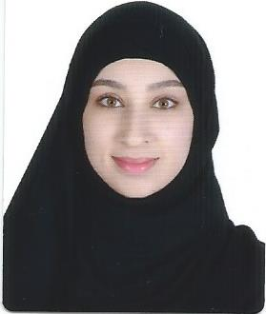

*Eman Sayed Jaffar Mohammed.*

*950604259*

*House:1560, Road:5157, Block:551*

*Al-Qurrayah*

*14.06.1995*

*33366934*

[*2moona17@gmail.com*](mailto:2moona17@gmail.com)

*To utilize my previous experience as an accountant, where I can apply**the skills and knowledge I have gained to benefit your company.*

***PERSONAL INFORMATION***

***Name and Surname:***

***CPR Number:***

***Address:***

***Date of Birth:***

***Phone number:***

***E-mail:***

***Objective:***

* Internet – Reading – Photography - Trip

***EDUCATION***

* ***2013 – 2018*** *University of Bahrain Major: B.Sc. in Accounting*
* ***2010 – 2013*** *Al-Shurooq Secondary Girls School (Grade A)*
* ***2001 – 2010*** *Al-Budaiya Primary Intermediate Girls School (Grade A)*

***EXPERIENCE***

***Courses***

* ***English Business Course*** *Millennium Training Centre*
* ***International Computer Driving License*** *Delmon Academy*

***03.2018 - 04.2018***

*Two months training in BKIC where I had learned how to generate statements of accounts, generate debit and credit notes (invoices), scanning, sending e-mail, writing letters and contacting other individuals using lots of commination skills.*

***01.2019 - Until now***

*Working in Dynamic Structures as a Front Desk Coordinator*

* *Follow-up of new tenders and looking for updates on previous/old tenders.*
* *Organize meetings and receive the guests.*
* *Responsible for making and receiving calls.*
* *Organizing trips for guests from outside Bahrain in terms of applying visa, Hala Bahrain services and Hotel booking.*
* *Applying for Bahraini Visa and Saudi Visa.*
* *Able to use Microsoft office programs effectively (ICDL Certificate).*
* *Good communication skills, good listener and I’m able to convey a message clearly.*
* *Time management, I can control the time spent on some activities to increase effectiveness or productivity.*
* *Effectively collaborative person, who can work under pressure.*
* *Ability and desire to learn new skills and improve existing capabilities.*

***SKILLS***

***HOBBIES***

* ***Reading books****, including Anthony Horowitz, Agatha Christie, Fyodor Dostoevsky.*
* ***Walking****, 3 kilometers of walking.*

